Practical 2 : Introduction to Classes:
//Program 1 : Create a simple class with data members and member functions.
//Demonstrate the use of class instances to access data and invoke member functions.

#include <iostream>
using namespace std;

// Class definition
class Test
{
public:
// Data member
int val;

// Member function
void show()
{
val=100;
cout << "Value: " << val << endl;
}
};

int main()
{

// Object will declareed here
Test t1;
t1.show();
return 0;
}

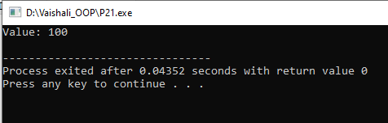

//P22:Write a c++ program using classes and object student
//to print name of the student,rollno. Display the same.

using namespace std;
#include<iostream>

class student
{
private:
char name[30];
int rollno;

public:
void getDetails(void);//member function to get students data
void putDetails(void);//member function to print students data
};

//member function definition outside of the class
void student::getDetails()
{
cout<<"Enter Name:";
cin>>name;
cout<<"Enter rollno"<<endl;
cin>>rollno;
}
void student::putDetails()
{
cout<<"Name is: "<<name<<endl;
cout<<"Rollno is:"<<rollno<<endl;
}

int main()
{
student s;
s.getDetails();
s.putDetails();
return 0;
}

